5.3.1 The Fundamental Theorem Worksheet

- Compute, if possible, the following definite integrals.

First we note that the function is continuous on , so we can apply FTCP2.

First we note that the function is continuous on , so we can apply FTCP2.

We note that is NOT continuous on , specifically because it is undefined at . Therefore, the FTCP2 does not apply and we currently have no way to determine such an area. We cannot proceed.

First we note that the function is continuous on , so we can apply FTCP2.

First we note that the function is continuous on , so we can apply FTCP2.

- The area under the parabola from 0 to 1.
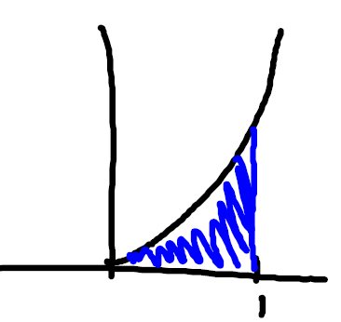
We note that is continuous on , so by the FTCP2 we know that:

- What is wrong with the following calculation?
The function is not continuous on , specifically because it is undefined at . Therefore, the FTCP2 does not apply and we currently have no way to determine such an area. We cannot proceed.

- Suppose . Find .

- Suppose . Find .
We note that .
Therefore
- Suppose . Determine each interval upon which the graph of is decreasing.

is never undefined.
when .

$$-5$$
$$+$$
$$-$$
$$+$$
$$MIN$$
$$MAX$$
$$5$$

is decreasing on the interval:

- Find the average value of the function on the interval .

Since is continuous on we know by the FTCP2 that:

- Suppose is a polynomial with . Given that: find the average value of on the interval .

Since is a polynomial then is a polynomial, so is integrable on the interval .

- Suppose . Determine all the intervals upon which is increasing.

We note that is a continuous function from , so we can apply FTCP1.

(remember to use the chain rule)

Note that when .
$$2$$
$$0$$
$$-2$$
$$-$$
$$+$$
$$-$$
$$+$$
$$MAX$$
$$MIN$$
$$MIN$$
is increasing on the following intervals:

